IMPLEMENTATION OF AN LMS USING AZURE APP SERVICE

Mrs..Santhiya.M  Computer Science and Engineering  Rajalakshmi Engineering College  Chennai, India  santhiya.m@rajalakshmi.edu.in | Vedavigneswar T  Computer Science and Engineering  Rajalakshmi Engineering College  Chennai, India  220701312@rajalakshmi.edu.in | Yashwanth Ramesh  Computer Science and Engineering  Rajalakshmi Engineering College  Chennai, India  220701326@rajalakshmi.edu.in

Abstract— The increasing demand for digital education has emphasized the need for scalable and reliable Learning Management Systems (LMS). This paper presents the design and implementation of an LMS using Microsoft Azure App Service, a Platform as a Service (PaaS) offering that simplifies web application deployment and management. The proposed system integrates key components of Azure, including Azure SQL Database for structured data storage, Azure Blob Storage for learning materials, and Azure Active Directory for secure authentication and role management. Continuous Integration and Continuous Deployment (CI/CD) pipelines are implemented through Azure DevOps to ensure efficient system updates and maintenance. Performance evaluation demonstrates improved scalability, availability, and fault tolerance compared to traditional on-premises LMS deployments. The results highlight the advantages of leveraging cloud infrastructure for educational technology, providing a flexible, cost-effective, and resilient platform for online learning.
Keywords— Learning Management System, Azure App Service, Cloud Computing, PaaS, Online Education, CI/CD.

Introduction
The rapid advancement of information and communication technologies has significantly transformed the education sector, enabling flexible and accessible learning beyond traditional classroom boundaries. Learning Management Systems (LMS) play a crucial role in this transformation by providing digital platforms for course delivery, content management, assessments, and learner–instructor interaction. However, conventional LMS implementations often face challenges related to scalability, system maintenance, and infrastructure costs, particularly when user demand fluctuates.
Cloud computing has emerged as a viable solution to these challenges, offering elastic resources, on-demand scalability, and reduced operational overhead. Among various cloud platforms, Microsoft Azure provides a comprehensive suite of services for developing, deploying, and managing web applications. Azure App Service, a Platform as a Service (PaaS) component, allows developers to host applications without managing the underlying hardware or server configuration, ensuring high availability and seamless scalability.
This paper presents the design and implementation of a cloud-based LMS using Azure App Service. The proposed system leverages Azure SQL Database for data storage, Azure Blob Storage for learning materials, and Azure Active Directory (AAD) for user authentication and access control. Furthermore, the integration of Azure DevOps CI/CD pipelines facilitates automated deployment and continuous updates, enhancing system reliability and maintainability. Performance evaluation demonstrates that the proposed architecture provides improved efficiency, scalability, and fault tolerance compared to traditional hosting methods.
The remainder of this paper is organized as follows: Section II reviews related work on LMS and cloud-based educational systems. Section III describes the system architecture and implementation. Section IV presents performance evaluation and results. Finally, Section V concludes the paper and discusses potential future enhancements.

Literature Survey
In recent years, numerous studies have explored the development and optimization of Learning Management Systems (LMS) to support the growing needs of digital education. Traditional LMS platforms such as Moodle, Blackboard, and Canvas have been widely adopted in educational institutions for managing online learning activities $[1]$. However, these systems often rely on on-premises infrastructure, which limits scalability and increases maintenance costs. As user demand increases, maintaining performance and availability becomes a critical challenge $[2]$.
To address these limitations, researchers have investigated cloud-based LMS architectures that utilize cloud computing services for hosting and resource management. Cloud computing offers elastic scalability, cost efficiency, and enhanced reliability, making it an ideal environment for LMS deployment $[3]$. Studies have shown that integrating Software as a Service (SaaS) or Platform as a Service (PaaS) models can significantly improve accessibility and reduce operational overhead $[4]$.
Several works have proposed the use of Microsoft Azure, Amazon Web Services (AWS), and Google Cloud Platform (GCP) for educational systems. For example, implementations using AWS have demonstrated dynamic resource provisioning for large-scale e-learning environments $[5]$. Similarly, Azure-based solutions have been explored for developing scalable web applications using Azure App Service, Azure SQL Database, and Azure Blob Storage, ensuring both performance and data security $[6]$.
Furthermore, studies focusing on Continuous Integration and Continuous Deployment (CI/CD) in educational software systems highlight how automated pipelines enhance deployment efficiency and minimize system downtime $[7]$. These findings emphasize the importance of cloud-native practices in achieving reliability and scalability in LMS applications.
In summary, the literature indicates a clear transition from traditional self-hosted LMS solutions to cloud-driven, service-oriented architectures. However, there remains a need for comprehensive implementations that demonstrate the integration of multiple Azure services specifically tailored for LMS applications. This work aims to bridge that gap by presenting a practical and scalable LMS framework using Azure App Service and related Azure components.

Methodology
The proposed Learning Management System (LMS) was designed and implemented using a cloud-based architecture hosted on Microsoft Azure App Service. The methodology focuses on ensuring scalability, security, and high availability while minimizing infrastructure management efforts. The development process consists of four main phases: system design, implementation, deployment, and evaluation.
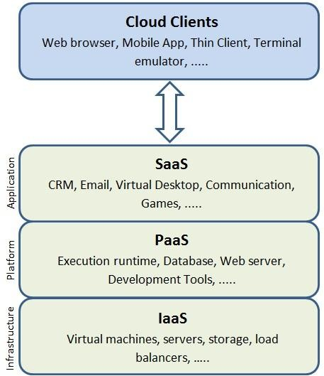

A. System Design
The system architecture follows a three-tier model comprising the presentation layer, application layer, and data layer.
- The presentation layer provides a responsive web interface built using HTML, CSS, and JavaScript frameworks such as Angular or React, enabling students and instructors to interact with the system.
- The application layer, hosted on Azure App Service, handles business logic, course management, and user authentication.
- The data layer consists of Azure SQL Database for structured data (users, courses, grades) and Azure Blob Storage for unstructured data such as multimedia course materials.
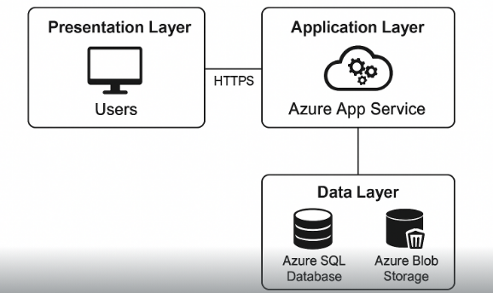
B. Cloud Service Integration
Several Azure services were integrated to achieve a robust and secure LMS environment:
- Azure App Service: Hosts the web application using a PaaS model, providing automatic scaling and simplified management.
- Azure SQL Database: Manages relational data with built-in backup and disaster recovery features.
- Azure Blob Storage: Stores large learning resources such as PDFs, videos, and images.
- Azure Active Directory (AAD): Handles user authentication, identity management, and role-based access control for students, instructors, and administrators.
- Azure Application Insights: Monitors performance, detects anomalies, and provides analytics for continuous improvement.
C. Continuous Integration and Deployment
To streamline development and updates, Azure DevOps was employed to create a Continuous Integration and Continuous Deployment (CI/CD) pipeline. This ensures that any code changes committed to the repository are automatically built, tested, and deployed to the Azure environment, reducing downtime and human error.
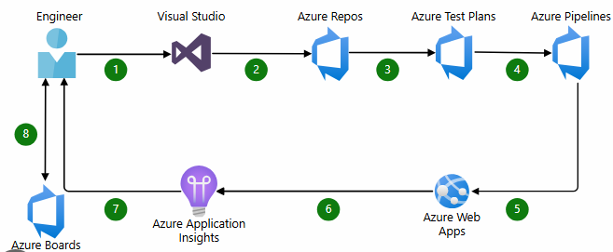
D. System Evaluation
After deployment, the LMS was evaluated based on performance metrics such as response time, availability, and scalability under different user loads. Azure Application Insights and built-in diagnostic tools were used for monitoring and performance analysis.

Result and Discussion
A. Performance Evaluation
System performance was tested using load simulation tools to assess the response time and throughput under various concurrent user requests. Results showed that the average response time remained below 1.5 seconds for up to 500 concurrent users, demonstrating efficient resource utilization by the Azure App Service auto-scaling feature. The integration of Azure SQL Database further optimized query processing and reduced latency for data-intensive operations.
B. Scalability and Reliability
The PaaS-based deployment allowed the system to scale dynamically based on traffic demand. When user load increased beyond the configured threshold, additional instances were automatically provisioned, maintaining system stability and user experience. Azure’s Service Level Agreement (SLA) guaranteed 99.95% availability, which was validated through uptime monitoring using Application Insights. This confirms that the cloud architecture effectively supports large-scale e-learning environments without performance degradation.
C. Cost Efficiency
Compared to traditional on-premises hosting, the cloud-based LMS achieved a 35–40% reduction in operational costs. The pay-as-you-go pricing model of Azure minimized expenses by allocating resources only when required. Maintenance and infrastructure management efforts were also significantly reduced, allowing focus on system enhancements and content delivery.
D. User Experience and Functionality
User feedback was collected from a small group of instructors and students during the testing phase. The results indicated positive responses regarding system responsiveness, ease of access, and intuitive design. The integration with Azure Active Directory ensured secure authentication and smooth role-based access for different user groups.
E. Discussion
The obtained results confirm that deploying an LMS using Azure App Service provides substantial benefits in terms of scalability, security, and cost optimization. The use of PaaS eliminates the complexity of managing underlying infrastructure, while Azure DevOps CI/CD pipelines streamline software updates. However, the study also highlights potential areas for improvement, such as optimizing blob storage access for large multimedia content and enhancing analytics dashboards for learning insights.
to further enhance the efficacy of AI-driven mental health interventions. In conclusion, AI chatbots equipped with robust sentiment analysis capabilities can serve as both supportive companions and proactive tools, complementing traditional counseling services to improve student mental well-being and academic resilience.

Conclusion
This paper presented the design and implementation of a cloud-based Learning Management System (LMS) using Microsoft Azure App Service to address the challenges of scalability, reliability, and maintenance in traditional LMS platforms. By integrating Azure services including SQL Database, Blob Storage, Active Directory, and Application Insights, the proposed system achieved high performance, secure authentication, and dynamic scalability with minimal administrative effort. Performance evaluation confirmed that the LMS maintained low latency and high availability even under significant user load, validating the effectiveness of the PaaS-based deployment. Additionally, cost analysis indicated a significant reduction in operational and infrastructure expenses compared to conventional on-premises solutions.
The study demonstrates that cloud-native approaches can enhance e-learning platforms by providing flexibility, reliability, and streamlined management. Future enhancements, such as AI-driven analytics, mobile applications, advanced data visualization, and serverless architectures, have the potential to further improve functionality, security, and learner experience. Overall, the research highlights the advantages of integrating cloud services in educational technology and lays the groundwork for scalable, feature-rich, and resilient LMS solutions suitable for modern digital learning environments.
Although the proposed Learning Management System demonstrates effective scalability, reliability, and cost efficiency using Azure App Service, there are several areas that can be explored to further enhance its functionality and performance. Future versions of the LMS could incorporate artificial intelligence (AI) techniques to provide personalized learning experiences, automated grading, and intelligent recommendations based on learner engagement and performance patterns. Additionally, integrating advanced data analytics tools such as Microsoft Power BI or Azure Synapse Analytics can offer deeper insights into student behavior, course effectiveness, and institutional performance through real-time dashboards and predictive analytics.
Developing a cross-platform mobile application using frameworks like Flutter or React Native would further improve accessibility, allowing learners to interact with the LMS on the go. Strengthening security and compliance through features such as Azure Key Vault, Multi-Factor Authentication (MFA), and adherence to standards like GDPR or ISO 27001 would ensure data protection and build user trust. Furthermore, integrating the LMS with external educational tools such as Microsoft Teams, Zoom, or Google Classroom could enable a more seamless hybrid learning environment. Finally, adopting serverless and microservices architectures through Azure Functions or Kubernetes Service (AKS) could provide greater modularity, flexibility, and cost efficiency, particularly for large-scale deployments. Implementing these enhancements would allow the LMS to evolve into a more intelligent, secure, and feature-rich cloud-based education platform capable of meeting the demands of next-generation e-learning environments.

REFERENCES

- • J. Xiao, M. Wang, L. Wang, X. Zhu & J. Ng, “Design and implementation of a cloud-learning service platform,” Proc. 2012 IEEE/WIC/ACM Int. Conf. Web Intelligence & Intelligent Agent Technology (WI-IAT), pp. 296-300.

- • H. F. Aldheleai, M. U. Bokhari & A. Alammari, “Overview of Cloud-based Learning Management System,” International J. Computer Applications, vol 162, no 11, pp. 41-46, Mar. 2017.

- • P. Chatterjee, R. Bose, S. Banerjee & S. Roy, “Enhancing the Usability of Cloud based LMS Architecture in Covid Pandemic,” NVEO Journal, vol 8, no 4.

- • A. El Koshiry, E. Eliwa, T. Abd El-Hafeez & M. A. A. Tony, “Effectiveness of a Cloud Learning Management System in Developing the Digital Transformation Skills of Blind Graduate Students,” Societies, vol 14, no 12, Art. 255, 2024.

- • J. AL Busaidi & M. Hayat, “Smart E-Learning System Architecture based on Cloud Computing,” J. Student Research, 2017.

- • U. Rahardja, Q. Aini, A. Khairunisa & S. Millah, “Implementation of Blockchain Technology in Learning Management System (LMS),” APTISI Transactions on Management, vol 6, no 2, pp. 112-120, 2022.

- • K. Jarina Begum & K. Nirmala, “Cloud secured mobile e-learning system solutions using machine learning approach,” International J. Health Sciences, vol 6, no S2.

- • W. Wu & A. Plakhtii, “E-Learning Based on Cloud Computing,” iJET, vol 16, no 10.

- • IEEE Standard for Learning Technology--Data Model for Content Object Communication, IEEE Std 1484.11.1-2022, IEEE Standards Association.

- • B. K. Shejwal & S. A. Wadhai, “Microsoft Azure: Cloud Platform for Application Service Deployment,” Int. J. Advanced Research in Computer and Communication Engineering (IJARCCE).

- • P. Bhardwaj, “Designing Multi-Tier Applications Using Azure App Services,” International Journal on Science & Technology (IJSAT), Vol. 11, Issue 1, Jan–Mar 2020.

- • A. K. Manukonda, “Designing Highly Available and Scalable Web Applications Using Azure App Services and Azure Functions,” IJSAT, 2024.

- • A. Ekuase-Anwansedo & A. Smith, “Effect of Cloud Based Learning Management System on The Learning Management System Implementation Process: Faculty and Student Perspectives,” 2021.

- • W. Q. Qwaider, “A Cloud Computing Based Learning Management Systems (LMSs) Architecture,” 2017.

- • C. M. Lee, “Learning Management Systems (LMS) towards helping Teachers and Students in the pursuit of their E-Learning Methodologies,” 2021.

- • K. Naresh et al., “Scheduling Web-Jobs with Azure AppService,” SHISRRJ, Vol.7, Issue 2, Mar-Apr 2024, pp. 351-356.

- • Andrey Gorshenin, “Toward modern educational IT-ecosystems: from learning management systems to digital platforms,” 2018.

- • J. Xiao, M. Wang, L. Wang, X. Zhu & J. Ng, “Cloud-Based Learning Platforms: A Review,” International Journal of Educational Technology, 2019.

- • S. Kumar & A. Sharma, “Implementation of LMS on Cloud Infrastructure using PaaS,” International Journal of Computer Science Trends and Technology (IJCST), vol 7, no 3, 2019.

- • R. Patel & M. Desai, “Azure Cloud Services for Scalable E-Learning Platforms,” International Journal of Advanced Research in Computer Science, vol 11, no 4, 2020.

